|  |
| --- |
| Circle Language Spec: Interfaces |

## Interface Aspect in System Interface

System aspects can be shown in the system interface notation as worked out in the *System Interfaces* articles in the *System Objects* chapter. The Interface aspect was not covered there, so this is a supplement to that documentation.

### Object-Interface in System Interface

The Interface aspect has *five* system commands, but only *two* of them apply to Objects. The other ones apply to references. The Interface aspect of an Object is controlled through the following commands:

Use As Interface

Object-Interface Get

The commands are placed inside the system interface inside a triangle that wraps together the members of the Interface aspect:

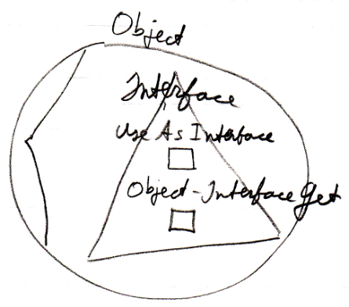

### Reference-Interface in System Interface

The Interface aspect has *five* system commands, but only *three* of them apply to Related Items:

Interface Set

Reference-Interface Get

Use Reference As Interface

The commands are placed inside a triangle, that wraps together the members of the Interface aspect:

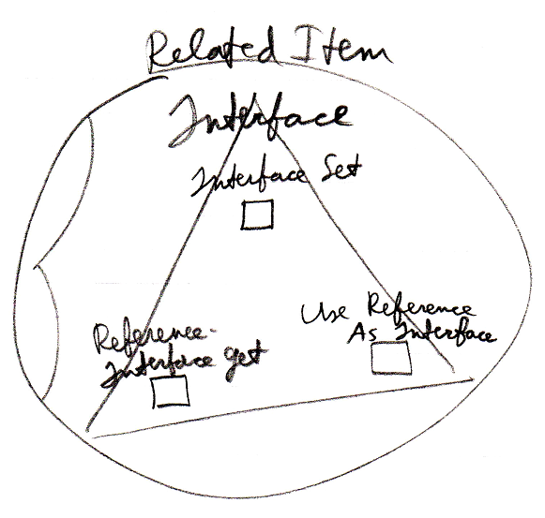

It works the same for a Related List Item as it does for a Related Item.

### Reference-Interface in System Interface of Related List

A list can centrally control the aspects of its items. Therefore, a list can control the Interface aspect of its items, centrally setting the Interface that all the items must support.

The system commands to do this are placed inside a triangle that wraps together the members to control the Interface aspect:

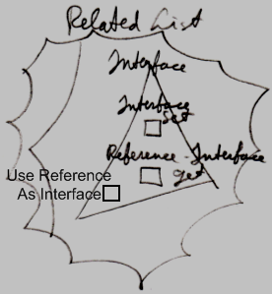

### Interface Merging in System Interface

The Interface Merging aspect only applies to Related Items. It is controlled through two commands:

Interface Merged Get

Interface Merged Set

The commands are placed inside the system interface inside a triangle, that wraps together the members of the Interface Merging aspect:

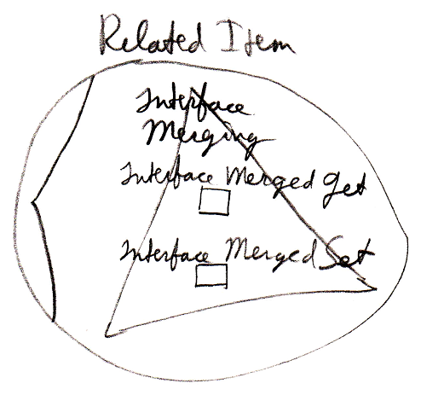

Interface Merging does not apply to Related List Items, because it does not seem to be practical there.